Subject Knowledge Audit
Health and Social Care

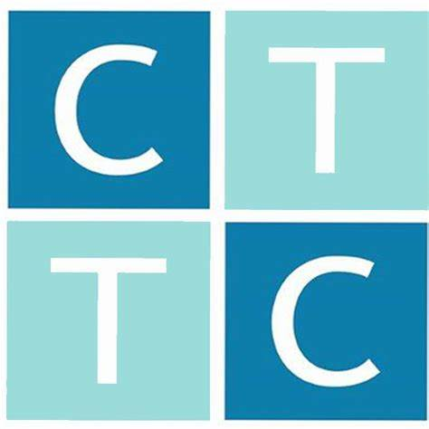

What does ‘Subject Knowledge’ mean in Health and Social Care?
Health and Social Care covers a diverse and broad range of topics, from human growth and development to the principles of care and safeguarding. While this breadth can be daunting, it is important to focus on the core areas that are most relevant to your specific teaching context, particularly in the context of Level 2 and Level 3 qualifications. No teacher can be an expert on every aspect of Health and Social Care immediately, and you will often encounter new topics or developments in the field. Part of your role will be to continually adapt, learn, and build expertise as needed.
In addition to the foundational knowledge, a key aspect of teaching Health and Social Care involves the practical skills and competencies needed to engage with and support learners effectively. Your familiarity with these skills will grow naturally as you observe and teach, and you will have access to a wide range of resources and advice from educational providers and industry professionals.
The Aim of a Subject Knowledge Audit:
This audit has been designed with three main purposes in mind:
- To help you identify your strengths and areas for development in Health and Social Care.
- To serve as a record of the work you are doing to develop your subject knowledge.
- To allow your training provider (CTTC) to track your progress in developing and increasing your subject knowledge.
How to Use a Subject Knowledge Audit
Throughout your training, you will be required to regularly revisit your subject knowledge audit and reflect on the progress you have made in expanding your knowledge base. Initially, this involves making an honest assessment of your knowledge in various aspects of Health and Social Care before starting the course (Pre-Course, or PC). Don’t worry about over- or underestimating your knowledge at this stage—your ability to accurately gauge your knowledge will improve with experience, observations, teaching, and discussions with your mentor.
After completing the initial audit, it can be tempting to try to improve in all areas simultaneously. However, it's crucial to prioritize your time, energy, and focus. The audit is structured to help you manage this, with curriculum understanding at the forefront, followed by key content areas like health and wellbeing, communication, and human growth and development. Some tasks, like reviewing statutory guidance, may take less time, whereas others, such as gaining a deep understanding of specific care practices or learning the details of assessment methods, will require more effort. Plan your learning priorities accordingly, and when in doubt, consult your subject or lead mentor for guidance.

Levels of Knowledge
At four points across your training, you will be required to assess and enter your level of knowledge for identified aspects of the Qualification. These levels of knowledge are:
Level 1
Levels of Knowledge
- Level 1: Little to no knowledge; requires significant study before teaching.
- Level 2: Basic understanding; confident to teach at Level 2 but needs more knowledge for Level 3.
- Level 3: Secure knowledge; comfortable teaching up to Level 3 but seeks further depth and observation opportunities.
- Level 4: In-depth knowledge, including advanced study; capable of teaching at any level with preparation.

You will update your subject knowledge audit four times: prior to starting the course (PC), then at the beginning of Term 1, Term 2, and Term 3. You can either type up your evidence of development at these points, or continually update it as your knowledge enhances.

Area of Health and Social care |  | PC | T1 | T2 | T3 | Evidence of Development
Growth and Development | Understanding the different stages of human development from infancy through to later adulthood.
Growth and Development | Factors influencing development, such as genetics, environment, lifestyle, and socio-economic factors.
Health and Social Care Values | Core principles such as dignity, respect, safeguarding, confidentiality, and promoting rights and choices.
Health and Social Care Values | Application of these values in everyday practice and interactions with service users.
Effective Communication in Health and Social Care | Different types of communication: verbal, non-verbal, written, and digital.
Effective Communication in Health and Social Care | Overcoming communication barriers and promoting effective communication in care settings.
Health and Wellbeing | Understanding physical, mental, and emotional health.
Health and Wellbeing | Health promotion and the importance of a healthy lifestyle, including diet, exercise, and mental health awareness.

Area of Health and Social care |  | PC | T1 | T2 | T3 | Evidence of Development
Working in Health and Social Care | Roles and responsibilities of health and social care workers.
Working in Health and Social Care | Understanding different settings, such as hospitals, care homes, and community care, and how they operate.
Working in Health and Social Care | The importance of teamwork, professional standards, and continuous personal development.
Equality, Diversity, and Rights in Health and Social Care | Understanding equality, diversity, and inclusion.
Equality, Diversity, and Rights in Health and Social Care | How to promote anti-discriminatory practice and ensure that everyone is treated fairly and respectfully.
Safeguarding and Protection | Identifying and reporting signs of abuse or neglect.
Safeguarding and Protection | Understanding the importance of safeguarding policies and procedures to protect vulnerable individuals.
Basic First Aid and Emergency Procedures | Introduction to basic first aid skills.
Basic First Aid and Emergency Procedures | Responding to emergency situations appropriately.

Area of Health and Social care |  | PC | T1 | T2 | T3 | Evidence of Development
Assessments | Internal Assessments: Coursework, practical assignments, and portfolio evidence demonstrating understanding and application of knowledge.
Assessments | External Assessments: Written exams or tests that evaluate knowledge on core topics, principles, and practical applications in health and social care settings.
Skills Developed | Practical Skills: Including basic first aid, effective communication techniques, and personal care skills.
Skills Developed | Analytical Skills: Understanding and applying health and social care values, evaluating case studies, and problem-solving.
Skills Developed | Reflective Skills: Developing self-awareness and the ability to reflect on one’s own practice for continuous improvement.
Skills Developed | Employability Skills: Preparing for roles within the health and social care sector, understanding professional conduct, and developing a foundation for further study or employment.
Career Pathways | Health: Nursing, midwifery, physiotherapy, ODP
Career Pathways | Social Care: Care work, social worker, support worker

